**UML Assignment**

1. Design and draw UML class diagram to represent an airline reservation system.

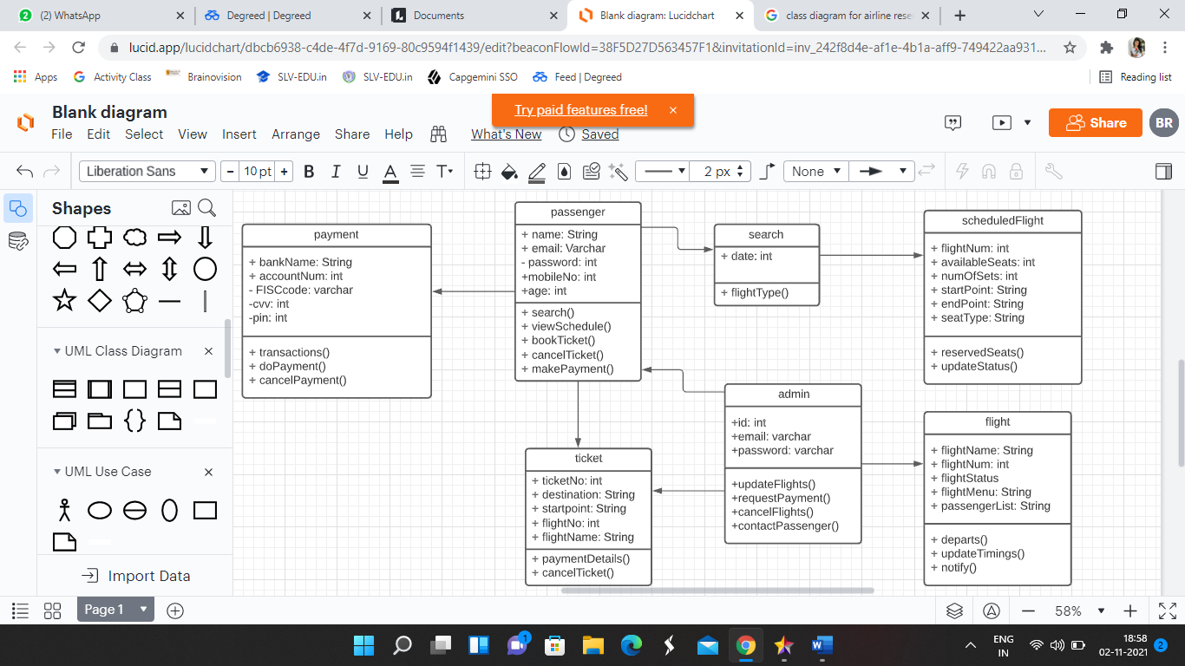

1. Design and draw UML class diagram with attributes, behaviour and class relationships for university.

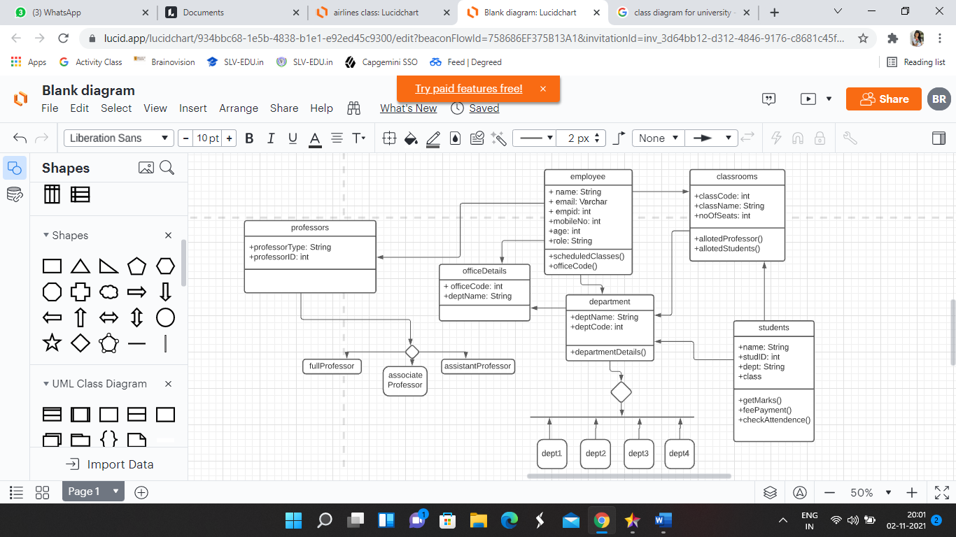

1. Draw a activity diagram for the student to enrol with a course.

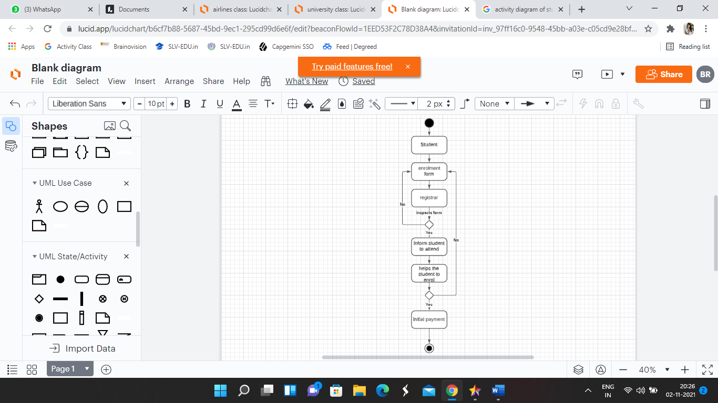

1. Draw a sequence diagram for creating new library user account by librarian.

